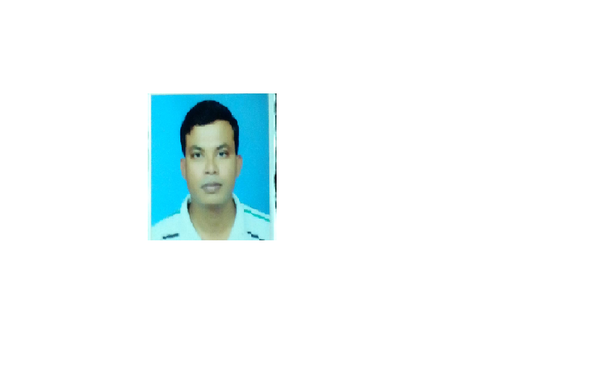

NITIN WAGHMARE DHANRAJ WAGHMARE

Mobile No. +918989942981

E-mail: nitinwaghmare603@gmail.com

Career Objective To secure a suitable position with an Establishment where my
Skills, knowledge and experience can be effectively utilized.

Educational – Bachelor of Arts (B.A.) from Maharishi Mahesh Yogi Vedic
Qualification Vishwavidyalaya, Madhya Pradesh – INDIA.

High School Certificate Exam, from Madhya Pradesh State
Open School – Bhopal, INDIA.

Bachelor of Theology (BTh) . from Emmanuel Bible College

Hyderabad ( 2012 to 2014 ).

Certificate of. Place of Baptism BEERSHEBA CHURCH OF GOD.
Baptism. Madhya Pradesh state. neemuch city.
Baptism was performed by Pr. k.v.Abraham.
15 November 2005

Languages Known: English & Hindi.

Work Experience

Worked as Teacher for 3 years with “Bethel Convent School”, Maladkar, Dist. Mansoor, MP – INDIA.
- Planning, developing and executing lessons that reflect the curriculum and the state’s core educational standards
- Adapting mathematics curriculum for individual, small group, and remedial instruction to meet the needs of identified students or subgroups of students
- Evaluating the academic and social growth of students
- Evaluating student progress and the ability to meet courses standards in mathematical knowledge and skills
- Establishing and maintaining standards of student behavior
- Planning and developing lesson plans and teaching outlines
- Employing a variety of methodologies in teaching and instructing pupils, including demonstrations, discussions, and lectures
- Utilizing educational equipment, such as materials, books, and other learning aids

Worked as Accountant for 1 year with “Kendriya Vidhyalay – CBSC School”, Neemuch – MP, INDIA.

- Providing general clerical/administrative support including photocopying and filing
undertaking reception duties including answering telephone and responding to queries and enquiries and dealing with visitors where appropriate on behalf of the Head teacher/Principal
- Taking notes at ad-hoc meetings as required
- providing administrative support for examinations and attendance including data inputting
- undertaking general financial administration
- updating/maintaining manual/computerized record/management information systems including system maintenance/back up files and provision of reports
- ordering supplies and equipment/maintain stock and classroom resources and arrange repair where necessary
- assisting in the clerical arrangements for trips/school events
- responsibility for pursuing pupil absence with parents including recording/ monitoring of absence and production of reports
- first point of contact regarding teacher absences/contact with supply agency/associated record keeping/processing of payments
- responsibility for pupil admissions – recording data/liaison other schools/class lists/timetables/management information and statistics returns
- responsibility for first aid and the welfare of students including direct contact with parents/guardians

Worked as Salesman for 1 year with “Riya Collection Mobile Phones”, Neemuch – MP, INDIA.
- Greeting customers who enter the shop.
- Be involved in stock control and management.
- Assisting shoppers to find the goods and products they are looking for.
- Being responsible for processing cash and card payments.
- Stocking shelves with merchandise.
- Answering queries from customers.
- Reporting discrepancies and problems to the supervisor.
- Giving advice and guidance on product selection to customers.
- Balancing cash registers with receipts.
- Dealing with customer refunds.
- Keeping the store tidy and clean, this includes hovering and mopping.
- Responsible dealing with customer complaints.
- Working within established guidelines, particularly with brands.
- Attaching price tags to merchandise on the shop floor.
- Responsible for security within the store and being on the lookout for shoplifters and fraudulent credit cards etc.
- Receiving and storing the delivery of large amounts of stock
- Keeping up to date with special promotions and putting up displays.

Worked as Salesman for 2 years with “Glory Collection Wear- Garments trading”, Neemuch – MP, INDIA.

Field work experience in M.P, A.P , M.H

MINISTRY OBJECTIVE
My ministry objective is for God alone to be glorified. Because of this objective, I long to preach the gospel, apply God’s word, and love His people. Christ has accomplished all and justified me; therefore, I live for Him out of gratitude for His finished work in satisfying God’s wrath and sealing my salvation. I must do whatever is allowed by God to reach others with the gospel and to cultivate growth in them to maturity in Christ. Furthermore, I seek to equip the saints for the work of the ministry. “Everyone has a ministry” is the mentality all Christians must possess. Finally, evangelists are who we are as Christians; meaning that evangelism is more than just something we participate in once a week, month, year, or lifetime. Rather, we should participate in evangelism on a daily basis as we take the name of Jesus with us.
CHURCH EXPERIENCE

- Oversee all Ministries of the Church
- Preach Sunday morning, Sunday evening and Wednesday evening
- Teach Sunday School
- Occasionally lead singing portion of worship service.
- Teach Wednesday night class and Sunday school
- Plan and coordinate youth summer camps and retreats
- Plan and lead Wednesday night youth worship
- Plan youth mission trips and mission activities
- Plan and Coordinate Youth Revival
- Prepare annual youth budget
- Counsel with youth
- Occasionally fill pulpit
- Develop overall youth ministry program
- Develop youth leadership committee
- Plan and coordinate Outreach ministry
• Guided Church in discovery and fulfillment of its calling and mission, including casting God’s vision, encouraging spiritual development, leading congregation, and expanding congregation’s participation in mission activities.
• Planned and delivered weekly sermons, prepared long-term preaching plans, and oversaw Sunday school.
• Strengthened and oversaw faith life by creating inviting community of faith, empowering leadership, coordinating and supervising weekly staff meetings, and leading weekly gatherings such as Bible study.
. Bible study classes, prayed with church members and guests, and visited with grieving church members.

My family testimony

My name Nitin and my testimony is as under:

When I was 3 year old, my mother got paralyzed, we went for exorcism, but it produced no result. We went to many temples and tookvotive, but it too didn’t produce any result. An aunty from church used to come to meet an aunty who lived in our neighbourhood. After seeing my mother’s condition she asked my mother “do you believe in Lord Jesus?”. Mother replied “I have read about him.” She told “ do come to church from tomorrow, we will pray for you.” At that time Paster uncle from was outside, only the aunty and some believers were there.

When they surrounded my mother and started praying, one by one seven evil spirits started leaving my mother. Seeing this I got frightened. Then, an aunty came to me and told to pray to Lord Jesus, and I followed her words.

Just then my mother got safe and sound, and after that day we started to fully believe Lord Jesus. The most important thing is that when my mother was in paralyzed, my sister was in womb. With the grace of God both were saved and safeguarded. From that time my father also began to believe in Jesus. My mummy and papa took “Bapatisma” (Baptism). And still I, my papa, mummy, sister and brother and me are devoted and serving Lord Jesus.

God’s call for mission

Lord enlightened me when I was 9 year old. In a midnight God resplendent with light and told me “Nitin I selected you for strayed and misguided “ people you have to follow the path shown by heavenly father and bring the people at right path by telling them gospel of the omnipresent.
It was the moment that stimulated me and serving to God with words of God.

Personal Profiles

Date of Birth : 13/04/1991
Place of Birth : Neemuch, Madhya Pradesh.
Nationality : Indian

Marital Status : Single

Signature of: _________________
NITIN WAGHMARE DHANRAJ WAGHMARE

Date:

